Climate Change

Jermaine W. Merritt

Central Piedmont Community College

BIO110-B1101

Professor Lawing

April 30, 2025

# Climate Change

# Introduction

Climate change is a long-term change in temperature and weather patterns on Earth, which occurs over several decades. Human activities cause abnormal changes in the weather, particularly from burning fossil fuels such as coal, oil, and gas, which unleash greenhouse gases into the atmosphere and trap heat, leading to global warming. This causes a waterfall of environmental and societal challenges. We must find an effective way to combat climate change for our future generation.

## Analysis

## What is climate change?

Climate change is a long-term change in Earth's average weather patterns and temperatures; human activities have caused this for years. These abnormal changes involve more than just rising temperature; they include shifts in precipitation, increased frequency of extreme weather events like droughts and floods, and rising sea levels caused by melting glaciers and ocean thermal expansion. The leading cause is to improve the greenhouse effect due to elevated emissions of gases such as carbon dioxide, methane, and nitrous oxide, resulting mainly from burning fossil fuels, deforestation, and intensive agriculture. We must also factor volcanic activity and solar variations that sway the climate over long time scales; the swift warming we observed today cannot be explained. Climate change affects our ecosystem, human health, and global economy, making it a global challenge.

***What is the relationship between climate change and the biosphere?***

Climate change and the biosphere are closely connected, as changes in the climate directly influence ecosystems and the living organisms within them. The biosphere, which includes all life on Earth, affects and is affected by the environment through processes like the exchange of greenhouse gases such as carbon dioxide and methane. When the climate shifts through rising temperatures, altered precipitation, or extreme weather, plants, animals, and microorganisms must adapt, migrate, or face potential extinction. These changes can disrupt ecosystems, influence species distributions, and alter natural cycles like migration and growth. Furthermore, human-induced climate change has intensified these effects by increasing greenhouse gas levels, warming the planet, and challenging the stability and functioning of the biosphere globally. Thus, climate change and the biosphere exist in a dynamic relationship that continuously impacts the other.

### What are greenhouse gases?

Greenhouse gases are a group of gases in the Earth’s atmosphere that can trap heat. When sunlight reaches the Earth’s surface, it warms the planet, and the Earth then emits this energy as infrared radiation. Greenhouse gases absorb this infrared radiation and re-emit it in all directions, including back toward the surface, which traps heat within the atmosphere and keeps the planet warm enough to sustain life. Common examples of these gases include carbon dioxide, methane, nitrous oxide, and water vapor. Their presence is crucial because without them, the Earth would be too cold; however, excessive greenhouse gases can lead to increased global warming and climate change.

**Figure 1**

Example of Greenhouse gases

***What is the evidence that climate change is changing?***

There is strong and diverse evidence showing that climate change is happening. Global temperatures have steadily increased, with recent decades being the warmest on record. The oceans are warming and absorbing much heat, leading to rising sea levels due to water expansion, and melting ice, ice sheets, and glaciers worldwide are shrinking. Arctic sea ice is declining rapidly, and snow cover is decreasing earlier in the year. Additionally, ecosystem changes, such as earlier plant blooming and shifting animal migrations, further indicate a warming planet. Scientific measures, from satellites to ice cores, consistently demonstrate that these changes are occurring faster than in the past and are primarily driven by human activities that increase greenhouse gases in the atmosphere. This comprehensive data confirms that climate change is a real and accelerating phenomenon affecting the entire Earth system.

**Figure 2**

Example of Climate Change.

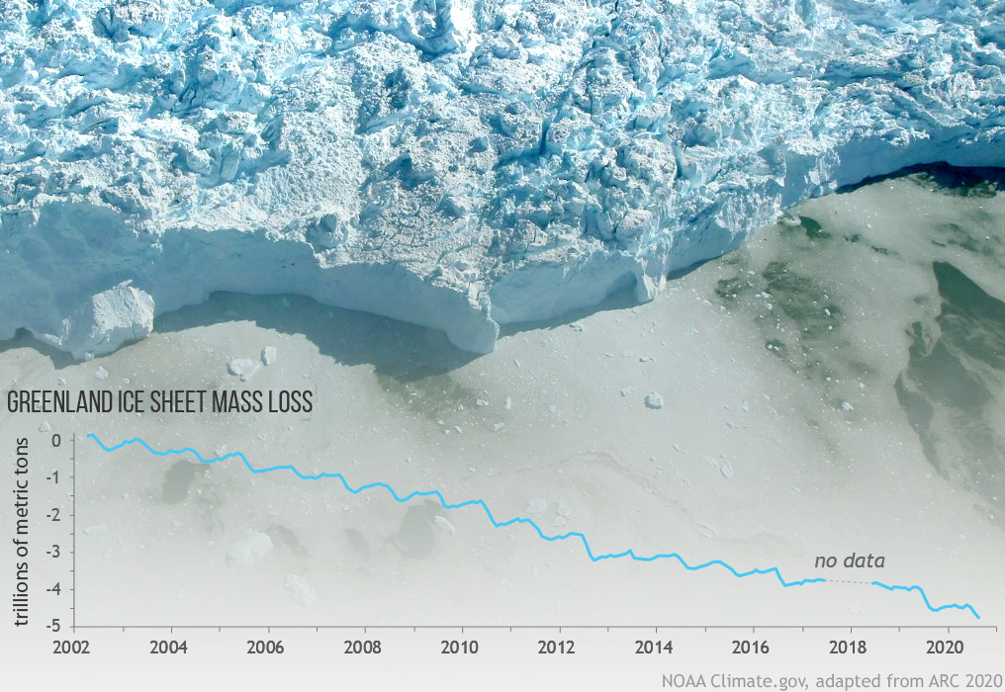

.

## Synthesis

## What is the role of carbon in climate change?

***What is the carbon cycle?***

Carbon plays a crucial role in climate change, primarily through its presence as carbon dioxide accumulates in the atmosphere, mainly from human activities. Activities like burning fossil fuels trap heat by absorbing and re-radiating infrared energy from the Earth's surface, enhancing the natural greenhouse effect and causing global temperatures to rise. This warming leads to various climate change impacts such as melting ice, rising sea levels, and altered weather patterns. The carbon cycle is the natural process through which carbon atoms continuously move between the atmosphere, living organisms, oceans, and the Earth’s crust. Crust. In this cycle, plants absorb carbon dioxide during photosynthesis; animals consume plants, and carbon is eventually returned to the atmosphere through respiration, decomposition, and volcanic activity. However, human-induced changes like fossil fuel combustion have disrupted this balance, releasing carbon stored for millions of years into the atmosphere faster than natural processes can absorb it, accelerating climate change. Thus, understanding the carbon cycle is essential to grasp how carbon influences Earth’s climate system and why controlling carbon emissions is vital for mitigating climate change.

**Figure 3**

Example of Carbon Dioxide

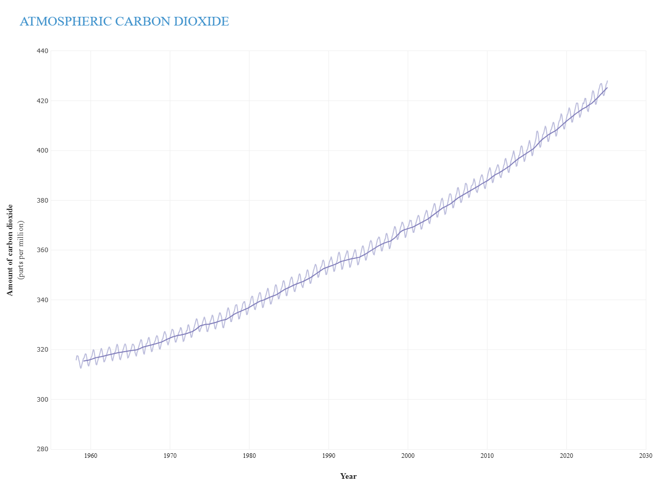

***What is photosynthesis?***

Photosynthesis is a natural process where green plants, algae, and some bacteria use sunlight to create food. They absorb light energy, typically from the sun, and convert it into chemical energy stored in sugar, like glucose. This process involves taking carbon dioxide from the air and water from the soil, then transforming these into oxygen and energy-rich compounds through a series of reactions inside special cell structures called chloroplasts. The green pigment chlorophyll plays a key role in capturing light energy. Photosynthesis is essential for life on Earth because it produces the oxygen we breathe and forms the base of the food chain by supplying energy to plants and, indirectly, to all other living organisms. Without this process, the planet’s ecosystems and atmospheric balance would not be sustainable.

**Figure 4**

Example of Photosynthesis

***What are fossil fuels?***

Fossil fuels are natural energy sources formed from the remains of ancient plants and animals that lived millions of years ago. Over long periods, these organic materials were buried under layers of earth and subjected to intense heat and pressure, transforming them into coal, oil, and natural gas. These fuels are rich in carbon and hydrogen, which release energy when burned, making them valuable for heating, electricity generation, and transportation. Because they take millions of years to form, fossil fuels are considered non-renewable resources, meaning they cannot be quickly replaced once used. Their widespread use has significantly shaped modern life, but raises concerns due to their environmental impact.

**Figure 5**

Example of Fossil Fuel

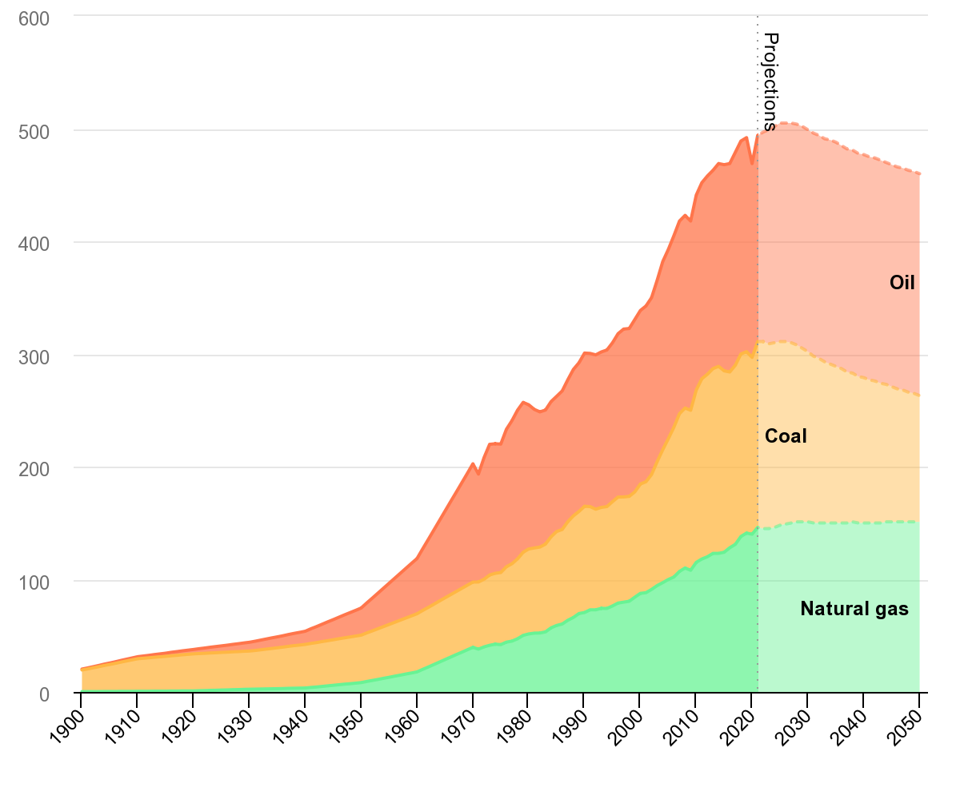

**What are the consequences of climate change?**

Climate change leads to many serious consequences affecting the environment and human societies. Rising global temperatures cause more frequent and intense heat waves, resulting in health problems and even death. Changes in weather patterns lead to increased droughts, flooding, and stronger storms, damaging agriculture, infrastructure, and natural ecosystems. Melting glaciers and ice caps contribute to rising sea levels, threatening coastal communities with erosion and flooding. Additionally, shifts in climate disrupt the habitats of many plant and animal species, pushing some towards extinction. Socially and economically, climate change exacerbates inequalities, disproportionately impacting vulnerable populations by threatening food and water security, displacing people, and increasing health risks.

**Figure 6**

Example of the consequences of Climate Change

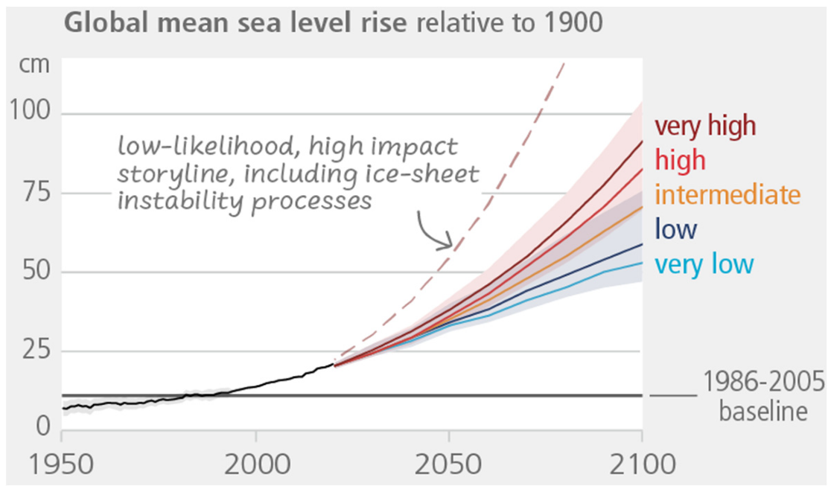

***How does climate change impact individuals and species?***

Climate change significantly affects both individuals and species by altering the environments they depend on for survival and well-being. For individuals, rising temperatures increase the risk of heat-related illnesses, worsen air quality, and contribute to the spread of diseases carried by insects like mosquitoes and ticks. Extreme weather events such as floods, droughts, and hurricanes can threaten homes, disrupt access to healthcare, and cause mental health challenges. Vulnerable groups, including children, older people, and low-income communities, often face greater risks due to limited adaptive capacity. Similarly, species experience habitat loss, shifts in geographic ranges, and mismatches in ecological timing, which can lead to decreased food availability, reduced reproductive success, or even extinction. For example, some marine animals suffer from warming oceans and ocean acidification, while terrestrial animals may be forced to migrate to cooler areas, disrupting ecosystems. These impacts emphasize the intertwined fates of humans and nature amid a changing climate.

**Figure 7**

Example of Climate Change impact

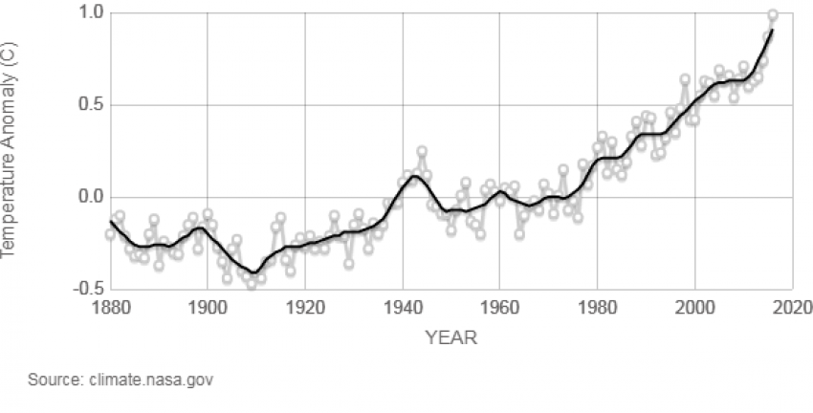

***How does*** ***climate change impact communities of organisms?***

Climate change significantly impacts communities of organisms by altering their habitats, behaviors, and interactions in ways that can disrupt the delicate balance of ecosystems. As temperatures rise and precipitation patterns shift, some species may adapt by changing their behaviors, physical traits, or migration patterns, while others may struggle to survive or even face extinction. This leads to shifts in geographic ranges, with animals and plants moving toward cooler areas, often resulting in the loss of native species and the spread of invasive species that can outcompete them. Additionally, climate change affects the timing of natural events such as flowering, migration, and breeding, potentially causing mismatches between species that depend on each other for food or pollination. These disruptions cascade through food webs, impacting species diversity and altering ecosystem functions. Furthermore, changing conditions degrade critical ecosystem services, such as food production, carbon storage, and habitat provision, affecting wildlife and human communities that rely on these resources. In summary, climate change destabilizes organism communities by forcing shifts in population dynamics, species interactions, and ecosystem resilience, often with negative consequences for biodiversity and ecological health.

**Figure 8**

Example of *climate change impact on communities of organisms*

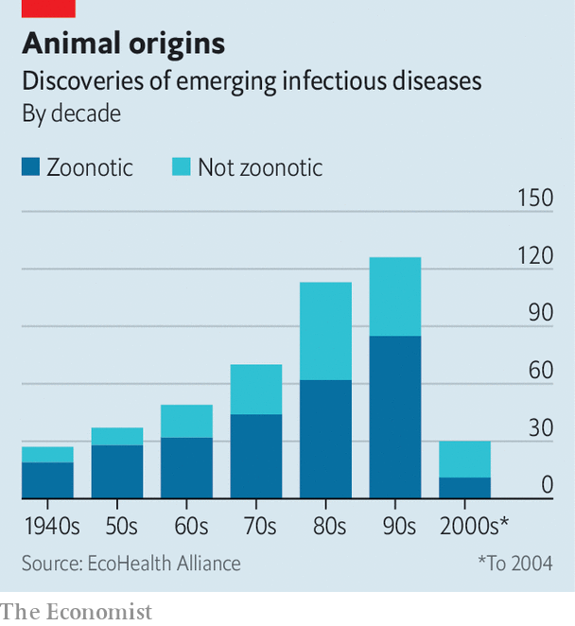

***How does climate change impact ecosystems globally?***

Climate change is a pressing issue that impacts ecosystems globally. It alters temperature and precipitation patterns, affecting how plants and animals grow, behave, and interact within their habitats. As the climate warms, many species are forced to migrate to cooler areas, disrupting existing ecosystems and sometimes leading to local extinction. These changes also affect the timing of natural events like migration, breeding, and flowering, causing mismatches between species that depend on one another for food or reproduction. Additionally, climate change promotes the spread of invasive species and diseases, which can outcompete native organisms and further destabilize ecosystems. These combined effects lead to reduced biodiversity and impair the essential services ecosystems provide to humans, such as food supply, clean water, and climate regulation, ultimately threatening both natural environments and human communities worldwide.

**Figure 9**

Example of climate change impact on ecosystems

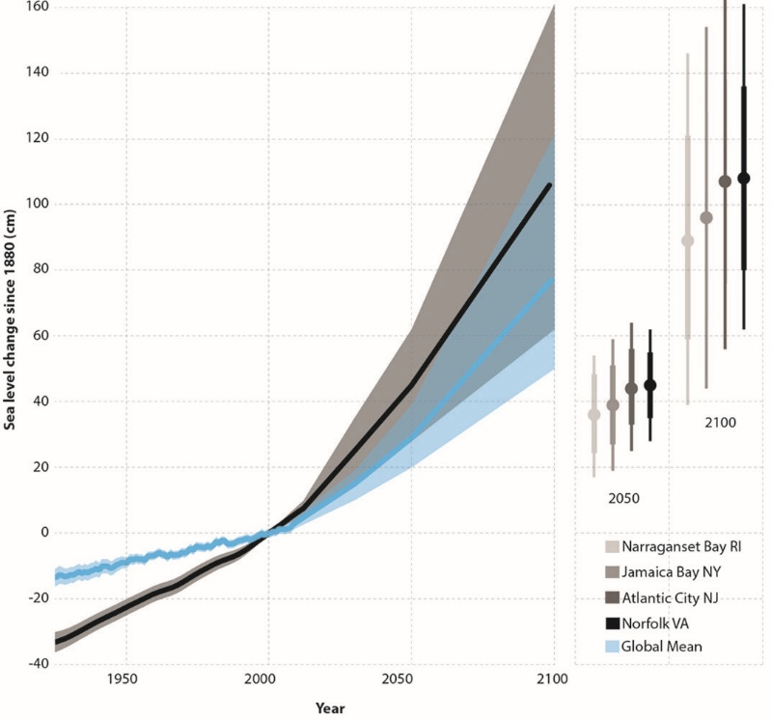

# My Plan

**How can individuals reduce carbon dioxide emissions?**

Individuals play a crucial role in reducing carbon dioxide emissions. By making thoughtful changes in their daily habits and lifestyle choices, they can significantly contribute to this cause. One practical approach is to minimize car travel by walking, biking, using public transportation, or carpooling whenever possible, as these options have significantly lower emissions than driving alone. Switching to energy-efficient appliances and using renewable energy sources such as solar or wind power at home can also considerably reduce household emissions. Additionally, being mindful about energy use, such as turning off lights and appliances when not in use and improving home insulation, helps save energy and decrease greenhouse gas output. Changing dietary habits by reducing meat consumption and minimizing food waste also plays a role, since food production contributes to carbon emissions. Together, these simple yet impactful decisions can collectively contribute to lowering an individual's carbon footprint and help mitigate climate change.

***Identify the factors contributing to a person’s carbon footprint and what that footprint signifies.***

Understanding one's carbon footprint is crucial. It refers to the total amount of greenhouse gases, such as carbon dioxide and methane, released into the atmosphere due to daily activities and consumption patterns. Several key factors contribute to this footprint, including the energy used at home for heating, cooling, and electricity; the type and amount of transportation they rely on; the food they consume, especially the proportion of meat and dairy products; and the goods and services they purchase and discard. Essentially, a carbon footprint signifies an individual's environmental impact regarding how much they contribute to global warming through their emissions. This understanding is vital as it highlights the areas where one can make lifestyle changes to reduce their environmental impact and help combat climate change. It also reflects broader wealth and consumption patterns, with higher carbon footprints typically found among individuals in developed countries or with higher incomes. Ultimately, a person's carbon footprint is a vital indicator of their role in the planet’s carbon cycle and the collective challenge of sustainability.

***Determine what food choices utilize less carbon to produce and transport?***

Choosing foods with a lower carbon footprint involves focusing on what and how they are produced and transported. Plant-based foods such as fruits, vegetables, whole grains, legumes, and nuts generally require less energy, land, and water than animal-based foods, resulting in significantly lower greenhouse gas emissions during production. Among animal products, red meats like beef and lamb have the highest carbon emissions, primarily due to methane released during digestion and the large amounts of land and feed required. Regarding transportation, emissions from moving food typically make up a small portion of the total carbon footprint, with most emissions occurring during farming and land use changes. However, air freight transport is an exception as it produces much higher emissions than shipping by boat or land, so avoiding air-freight foods can also reduce carbon impact. Ultimately, selecting locally grown seasonal produce, minimizing red meat consumption, and favoring plant-based foods effectively limit carbon emissions from production and transport.

**What is meant by alternative energy?**

Alternative energy, which refers to sources that substitute conventional fossil fuels like coal, oil, and natural gas, significantly reduces reliance on polluting fuels. These energy sources are typically derived from natural resources that are either renewable or have a much lower environmental impact compared to traditional fuels. Unlike finite fossil fuels, which release significant amounts of greenhouse gases when burned, alternative energy sources are cleaner and more sustainable. Examples include solar power harnessed from sunlight, wind energy captured through turbines, geothermal heat from beneath the Earth’s surface, and hydropower generated from flowing water. Alternative energy aims to provide dependable power while minimizing harmful environmental effects.

***Identify the pros and cons of various forms of alternative energy.***

Alternative energy sources offer numerous benefits and drawbacks that vary depending on the type of energy. Solar energy is widely praised for being clean and renewable, producing no greenhouse gas emissions during operation, and requiring minimal water use; however, it can be expensive to install and depends heavily on consistent sunlight, making it less reliable in some regions. Wind energy similarly provides a renewable, low-emission power source with relatively low operating costs and the ability to generate jobs. Still, it faces challenges due to its intermittent nature, noise, visual impact, and potential harm to wildlife. Hydropower can generate large amounts of electricity consistently and supports water management, yet it can cause environmental disruptions, such as habitat alteration and changes in water quality. Geothermal energy stands out for its reliability and small land footprint, offering a constant and clean power supply, but it is often limited by location and has high initial costs. Biomass energy can reduce waste and provide a steady energy supply, yet concerns exist regarding deforestation, emissions of pollutants, and efficiency. Understanding these pros and cons is essential for making informed decisions about integrating alternative energy sources into an effective and sustainable energy mix.

***Assess the beneficial and detrimental points surrounding nuclear power generation.***

Nuclear power generation offers significant benefits, notably its ability to produce large amounts of electricity with minimal carbon emissions, making it a key player in combating climate change and reducing air pollution. Unlike many renewable sources, it provides a reliable, consistent energy supply that is not dependent on weather conditions, which helps maintain grid stability. Additionally, nuclear energy supports economic development by creating high-paying jobs and contributing to local economies. However, there are notable challenges associated with nuclear power. The production of radioactive waste poses long-term environmental and safety concerns, as this waste remains hazardous for thousands of years and lacks a universally accepted permanent disposal solution. High initial capital costs and lengthy construction timelines also hinder the expansion of nuclear facilities. Furthermore, public perception is often negatively influenced by fears of accidents and associations with nuclear weapons proliferation, despite strict safety regulations and the rarity of incidents. While atomic energy is a powerful tool for sustainable energy, it requires careful management of its risks and public acceptance to be a successful component of the future energy mix.

**What are some technology solutions to climate change?**

Technology offers a wide range of solutions to climate change by reducing greenhouse gas emissions and enhancing sustainability. Renewable energy technologies such as solar, wind, geothermal, and hydroelectric power replace fossil fuels with cleaner alternatives, significantly cutting carbon emissions. Innovations in energy efficiency, including advanced batteries and smart grids, optimize energy use to reduce waste and demand. Carbon capture and storage also remove carbon dioxide from the atmosphere, preventing further warming. Digital tools such as artificial intelligence and satellite monitoring help identify emission sources and track environmental changes, aiding in more targeted climate action. Advances in sustainable transportation, like electric vehicles and enhanced public transit systems, also play a crucial role in lowering emissions from one of the largest contributing sectors. With supportive policies and global cooperation, these technological developments form a comprehensive approach to combating climate change and promoting a more sustainable future.

***Describe how new technologies may be used to lessen the impact of climate change.***

New technologies offer powerful tools to reduce the impact of climate change by targeting both the sources of greenhouse gas emissions and the consequences they cause. Advanced carbon capture and storage techniques can trap carbon dioxide emissions from industrial processes and power plants, preventing them from entering the atmosphere. Renewable energy innovations, such as improved solar panels, wind turbines, and tidal energy systems, replace fossil fuels with cleaner alternatives, drastically cutting emissions. Additionally, artificial intelligence and satellite monitoring enable precise identification and management of emission hotspots, allowing for more targeted climate action. Innovations in energy efficiency, including more intelligent buildings and electric vehicles, reduce energy consumption while maintaining performance, limiting further environmental harm. Together, these emerging technologies curb emissions and support adaptation and resilience against the effects of climate change, paving the way for a more sustainable future. This comprehensive approach is critical to slowing global warming and mitigating its potentially devastating impact.

***Examine ways in which genetic engineering could be used to combat the effects and causes of climate change.***

Genetic engineering offers promising avenues to both combat the causes of climate change and alleviate its effects by enhancing the resilience and sustainability of agricultural systems. One significant approach involves developing genetically modified crops that can endure harsh environmental conditions such as drought, extreme temperatures, and pests, which are becoming more prevalent due to climate change. For instance, scientists have engineered drought-tolerant varieties of staple crops like rice, wheat, and maize, enabling stable food production despite adverse weather patterns. Additionally, genetic engineering can improve the efficiency of photosynthesis in plants, allowing them to capture more atmospheric carbon dioxide and store it in their tissues and soil, thereby reducing greenhouse gas concentrations. Beyond plants, gene editing tools like CRISPR have been used to create livestock better adapted to heat stress, such as heat-tolerant cattle with shorter hair, which minimizes heat absorption and improves animal welfare. Moreover, modifying soil microbes and plant root systems through genetic techniques can enhance carbon sequestration in soils, prolonging the storage of carbon and further mitigating climate change. These innovations reduce emissions and promote sustainable farming practices that require fewer resources like water and fertilizer, mitigating agriculture's environmental footprint. While challenges remain in regulatory acceptance and public perception, the continued use of precise genetic engineering holds great potential as a key tool in addressing climate change's causes and consequences.

# Conclusion

In conclusion, climate change represents one of the most urgent and complex challenges facing humanity and our planet today. Its impacts are widespread, affecting natural ecosystems, weather patterns, sea levels, human health, and economic stability across the globe. Human activities, notably burning fossil fuels and deforestation, have accelerated this process, leading to unprecedented warming and environmental disruption. While the situation is dire, there remains hope through global cooperation, technological innovation, and a commitment to reducing greenhouse gas emissions. By investing in sustainable energy, protecting natural carbon sinks, and enhancing resilience to climate impacts, society can work towards a more stable and sustainable future, limiting the worst consequences of climate change and safeguarding the well-being of current and future generations.

# References (Works cited page)

Bell, J. G., Samost, M., Wolford, L. L., Sipe, M., Starodub, R., Belanger, B., Do, G., Donati, C., O'Brien, L., & Nicholas, P. K. (2023). Health consequences of climate change: continuing education opportunities for health professionals in the United States.*The Journal of Continuing Education in Nursing, 54*(12), 561-566. <https://doi.org/10.3928/00220124-20231013-02>

Coffield, S. R., Hemes, K. S., Koven, C. D., Goulden, M. L., & Randerson, J. T. (2021). Climate‐driven limits to future carbon storage in California's wildland ecosystems.*AGU Advances, 2*(3 )<https://doi.org/10.1029/2021AV000384>

Dye, A. W., Houtman, R. M., Gao, P., Anderegg, W. R. L., Fettig, C. J., Hicke, J. A.,

Kim, J. B., Still, C. J., Young, K., & Riley, K. L. (2024). Carbon, climate, and

natural disturbance: a review of mechanisms, challenges, and tools for

Understanding forest carbon stability in an uncertain future.*Carbon Balance*

*and Management, 19*(1), 35. <https://doi.org/10.1186/s13021-024-00282-0>

Gianfredi, V., Mazziotta, F., Clerici, G., Astorri, E., Oliani, F., Cappellina, M., Catalini, A., Bernardo Maria Dell’Osso, Pregliasco, F. E., Castaldi, S., & Benatti, B. (2024). Climate change perception and mental health. Results from a systematic review of the literature.*European Journal of Investigation in Health, Psychology and Education, 14*(1), 215. <https://doi.org/10.3390/ejihpe14010014>

Trapero, F. G. A., Leal, E. M. G., & Kim, J. (2023). Effectiveness of the voluntary disclosure of corporate information and its commitment to climate change. *Global Journal of Environmental Science and Management, 9*(4), 1033-1048. <https://doi.org/10.22035/gjesm.2023.04.25>

Uyar, Nehir. "Spatiotemporal Dynamics of Carbon Storage in Utah: Insights from

Remote Sensing and Climate Variables."*Sustainability*, vol. 17, no. 5, 2025,

pp. 1976*. ProQuest Central*, https://login.proxy035.nclive.org/login?url=https://www.proquest.com/scholarly-journals/spatiotemporal-dynamics-carbon-storage-utah/docview/3176370711/se-2, doi: <https://doi.org/10.3390/su17051976>.